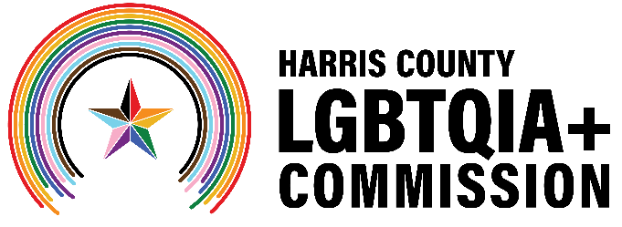
Meeting Agenda: Harris County LGBTQIA+ Commission
Wednesday, January 21 at 6:30 p.m.
In-Person at the Montrose Center, Rm 112/113
401 Branard St, 1st Floor, Houston, TX 77006
Virtual via Zoom: Click here to join.
Meeting ID: 926 9392 4078
Passcode: 318011
Call in (audio only): +1 (346) 248-7799

Commission Members: Victoria Cordova, Matthew Donovan, Ramiro Fonseca, Maria Gonzalez, PhD, Christopher Lester, Thomas Lopez, Brandon Mack, M.Ed, Kylie McNaught, Diamond Stylz, Ryan Wilson
The meeting will be a hybrid meeting. Members of the public sign up to give public comment by Zoom or telephone at the top of the meeting. To make public comment, email LGBTQIA@harriscountytx.gov.
- Call to Order
- Public Comment (limit to 3 minutes per person if less than 20 speakers, 1 minute per person if more than 20 speakers)
- Harris County Public Health Presentation
- Joint Meeting with City of Houston Mayor’s LGBTQ+ Advisory Board
  - Introductions
  - Alignment and Goals
- Greater Houston LGBTQ+ Community Summit Session
- Committee Updates
  - Communications
  - Advocacy
  - Community Engagement
- Adjournment

