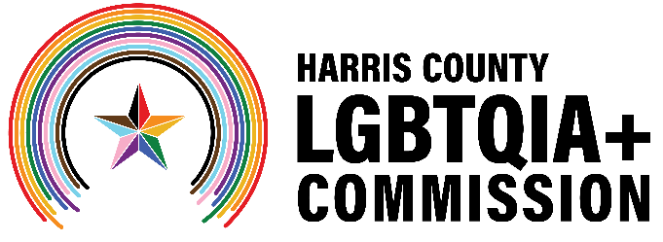
Harris County LGBTQIA+ Commission
lgbtqia.harriscountytx.gov
Meeting Minutes
Date: Wednesday, September 17, at 6:30 p.m.
Location: the Montrose Center and Zoom (Hybrid)

Commission Members: Victoria Cordova, Maria Gonzalez, Brandon Mack, Giovanni Rosselli, Diamond Stylz and Thomas Lopez
Absent: Matthew Donovan, Ramiro Fonseca, Mo Jenkins, Kylie McNaught and Brad Pritchett
Harris County Staff: Austin Davis Ruiz
- Call to Order
  - Commission Vice Chair Brandon Mack called the meeting to order at 6:49 p.m.
- Welcome to New Commission Member Matthew Donovan
  - Commission Vice Chair Brandon Mack announced Matthew Donovan as the newest member of the Commission. Matthew was not in attendance.
- Public Comment
  - Two community members, Christopher Lester and Jack Valinski, observed the meeting but had no formal comments.

- Harris County Sheriff's Office Policy and Law Enforcement Liaison
  - The Harris County Sheriff’s Office is exploring hosting an HIV/STI testing event in partnership with Pride Houston 365 and the Commission. The community engagement committee will lead the initial planning conversations.
  - The Commission hopes to meet the agency’s new LGBTQIA+ liaisons at one of their upcoming meetings.

- Subcommittee Assignments
  - Communications
    - The communications committee will explore celebrating LGBTQ History Month in October by highlighting The Banner Project on social media.
    - The communications committee will introduce Matthew Donovan to the community on its social media channels.
  - Advocacy
    - Reach out to the new City of Houston’s LGBTQ Advisory Board to introduce the Commission and discuss potential collaboration opportunities.
    - Explore Harris County Commissioners Court's recognition of LGBTQ History Month through a consent agenda item or a formal resolution.
  - Community Engagement
    - Community partners that participated in the January 2025 Houston LGBTQ+ Community Summit at the Montrose Center continue to gather to discuss future initiatives.
- Announcements
  - The 48th Annual Gay Softball World Series will be in Houston, Sept. 21-27.
  - Harris County Precinct 4’s 3rd Annual Hispanic Heritage Month Festival and Community Town Hall, Sept. 27, noon to 4 p.m. at Bayland Community Center.
  - Families with Pride hosted by Houston City Council Member Abbie Kamin and the Greater Houston LGBTQ+ Chamber of Commerce, Oct. 18, 9 a.m. to noon, Discovery Green.
- Adjournment
  - Commission Vice Chair Brandon Mack ended the meeting at 7:41 p.m.

