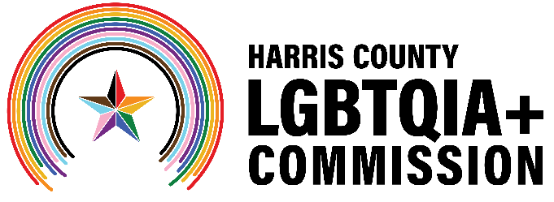
Harris County LGBTQIA+ Commission
lgbtqia.harriscountytx.gov
Meeting Minutes
Date: Wednesday, January 21, 2026, at 6:30 p.m.
Location: the Montrose Center and Zoom (Hybrid)

Commission Members: Diamond Collier, Victoria Cordova, Matthew Donovan, Ramiro Fonseca, Maria Gonzalez, Christopher Lester, Thomas Lopez, Brandon Mack, Kylie McNaught, Ryan Wilson
COH Mayor’s LGBTQ+ Advisory Board: Kevin Aloysius, Taylor Barner, Elia Chino, Nora Dayton, Mario Gates, Reesa Hedrick, Carl Josehart, Clay Melder, Kevin Nguyen, Jorge Ramos, Lou Weaver
Harris County Precinct 4 Staff: Talya Morris and Austin Davis Ruiz
Harris County Public Health Staff: Leah Barton, Dr. Ericka Brown
Harris County Precinct 1 Staff: Spencer Lively
- Call to Order
  - The meeting was called to order at 6:35 p.m. Attendees introduced themselves by name and affiliation before proceeding to the agenda.
- Public Comment
  - Jack Valinski introduced himself, shared his past and current advocacy for the LGBTQIA+ community and encouraged members of the LGBTQIA+ community to consider running for elected office or getting involved in political campaigns.

- Harris County Public Health Presentation
  - Leah Barton and Dr. Ericka Brown of Harris County Public Health (HCPH) presented an overview of county health programs and services, emphasizing HIV/STI rates, prevention and treatment. They noted that Harris County’s rates exceed state averages and discussed opportunities for the Harris County LGBTQIA+ Commission and the City of Houston’s LGBTQ+ Advisory Board to act as referral sources, provide participant feedback, and share HCPH resources within their networks. Barton serves as the executive director of HCPH, and Brown is the director of the community health and wellness division at HCPH.

- Joint Session with the City of Houston’s LGBTQ+ Advisory Board
  - Clay Melder, chair of the City of Houston’s LGBTQ+ Advisory Board, and Brandon Mack, vice chair of the Harris County LGBTQIA+ Commission, led a discussion on the formation, structure, and priorities of their respective bodies, including committee makeup, appointments, and opportunities for alignment. The groups emphasized a shared goal of serving as an extension of the LGBTQIA+ community.
  - The groups agreed to schedule a recurring joint meeting to continue discussions on mission alignment and potential joint events.

- Greater Houston LGBTQ+ Community Summit Session
  - The City of Houston’s LGBTQ+ Advisory Board and the Harris County LGBTQIA+ Commission will have an hour-long joint session at the Greater Houston LGBTQ+ Community Summit in February, hosted by a coalition of more than two dozen local LGBTQ+ organizations. There was a discussion of the session format, topics and resources. The City of Houston LGBTQ+ Advisory Board and the Harris County LGBTQIA+ Commission will hold a one-hour joint session at the Greater Houston LGBTQ+ Community Summit in February. Members discussed the potential session format, topics, and calls to action.

- Adjournment
  - Commission Vice Chair Brandon Mack ended the meeting at 8:17 p.m.

