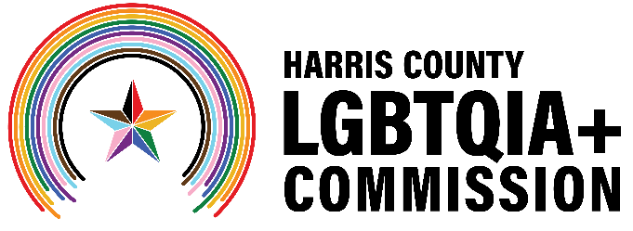
Meeting Agenda: Harris County LGBTQIA+ Commission
Wednesday, July 16 at 6:30 p.m.
In-Person at The Montrose Center
Virtual via Zoom: Click here to join.
Meeting ID: 978 0917 5351
Passcode: 163892
Call in (audio only): +1 (346) 248-7799

Commission Members: Victoria Cordova, Mo Jenkins, Ramiro Fonseca, Maria Gonzalez, PhD, Brandon Mack, M.Ed, Kylie McNaught, Kevin Nguyen, Giovanni Rosselli, Diamond Stylz, Victor Lopez, Brad Pritchett
The meeting will be a hybrid meeting. Members of the public sign up to give public comment by Zoom or telephone at the top of the meeting. To make public comment, email LGBTQIA@harriscountytx.gov.
- Call to Order
- Public Comment (limit to 3 minutes per person if less than 20 speakers, 1 minute per person if more than 20 speakers)
- Pride Press Conference
- Candidates for the Harris County LGBTQIA+ Commission – Discussion & Voting
- HCSO Updates
  - Testing Event
- Book Fair Event – Saturday, August 2
  - Partnership Opportunity
  - Day of Volunteers
- Tony’s Place Visit
- Subcommittee Assignments
  - Communications
  - Advocacy
  - Community Engagement
- Announcements
- Adjournment

